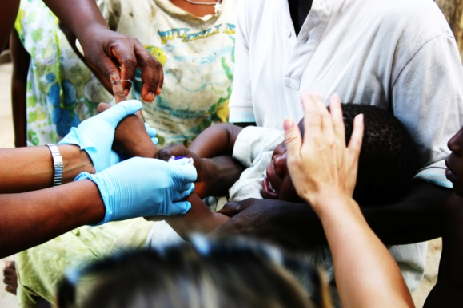
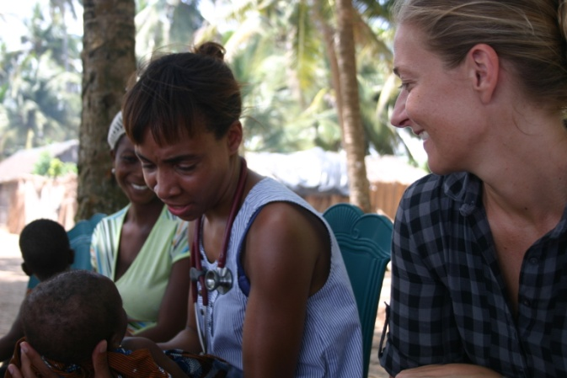
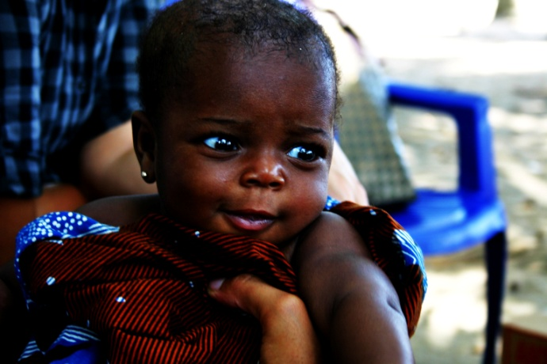

SHF
Volunteers Programme
2011

Foundation Profile
Sail Harbour Foundation is a non-profit organisation working in conjunction with Sail Harbour Resort Community to develop rural communities along the Badagry Creek, Nigeria. Our first project is the development of the Ago-Ajo, Moba and Taffi villages. Our aim is to gradually and systematically improve the lives of 1,000 people in year one to 12,000 by year five.
Our strategy is to establish sustainable villages through investment and interventions in five key sectors:
- Agriculture: encouraging market worth product of existing products
- Education:
- Environment,
- Health, and
- Infrastructure

Location Foundation’s primary focus
Lagos , Nigeria: Osolu Kingdom, along Badagry Creek, Ojo LGA.
This programme provides you with hands-on experience and helps you to see, experience and understand life in rural Nigeria. We provide volunteers with the opportunity to decide which aspect they are interested in working depending on their flexibility.

Opportunities are available in a wide range of fields and tailored to fit a participant's needs.
- Social/Field work
- Data collection and statistics
- PR: publicity and marketing

Project highlights
With the growing potentials of the Foundation’s activities the following Programmes and Proposals have been projected or are currently being run-
- Adopt a School Programme: supporting the primary and basic education within Moba's communities and its neighbouring villages
- New community centre for Moba, Taffi and Pete-Pete village
- School feeding programme for L.A. Nursery and Primary School, Sea Beach Moba
- Solar solution: light for 32 villages and 8 primary schools
- Advocacy for malaria prevention and malaria treatment programme (now referred to as the Medical Outreach Mission
- Financial literacy programme for rural communities
- New primary healthcare centre
- Providing access to clean drinking water: rehabilitation of boreholes and wells
- Empowering women: arts and crafts entrepreneurship
- Empowering women: women's rights advocacy
- Natural environment: sanitation, hygiene and waste management
Our volunteering programme is designed to to help the foundation with the implementation of these programmes.

Methods

The operating schema for Sail Harbour Foundation Volunteer Program will entail the following:
- Volunteer Recruitment
- Screening Volunteers
- Selecting ("Hiring") Volunteers
- Orienting and Training Volunteers
- Supervising (delegating, evaluating, addressing issues, rewarding, etc) Volunteer and Staff Relations
Developing Goals and Objectives
The Sail Harbour Foundation volunteer program has been created to reflect the goals and objectives of the organization and enhance the efficient implementation of its activities. Consequently the following goals and objectives have been highlighted to assist in the planning and evaluation phase of volunteer recruitment i.e. -
- Setting out what as clear as possible the services the volunteer will be asked to perform,
- Ensuring that volunteers have the qualifications to provide the service required;
- Specifying time allotment the volunteer will be required to commit;
- Determining how much training needed to prepare the volunteers to carry out the tasks successfully

Task Assignment
In order to meet the needs of both the organization and the volunteer a simple scheme for the assignment of tasks has been set out to follow the following guidelines
- Define the tasks
- Matching the Volunteer to the task or specific program
- Determine and capability of Volunteers
- Develop a list of potential candidates
- Assignment of a supervisor for the Volunteer
- Interviewing and assessment of the Volunteer
- Assignment of tasks to the Volunteer
- Providing adequate and appropriate orientation
Evaluation of Volunteers
Periodic evaluation of Volunteers will enable the foundation with ways of measuring how the program is progressing both on an individual and programmatic level. i.e. the effectiveness and efficiency of the volunteer program at contributing to the organization’s mission.

Typical Volunteer
Volunteers are placed on project in their area of interest if and when available. We try to ensure that placements are made in areas, i.e. communities we consider safe for our participants.

Application Process Involves
- In-Person Interview when feasible
- Phone Interview
- Previous volunteering experience (if available)

Qualifications
There are no special skills required by Volunteers for SHF. Selection will be based on the assessment and evaluations made during interviews. Note that these interviews are merely a protocol observed to get to know the candidates better and assess their areas of interests and possible contributions to our organization.
A few requirements must however be meet -
- (we might have rewarding kids as a part of the school programme)
- Candidates must be healthy and fit enough to adapt to working where project conditions may be strenuous (for field works)

Languages
- English: Oral and written (were volunteers are required to occasionally give written reports of their activities)
- Spoken Yoruba will be useful. This is not a requirement though as Foundation will ensure that non Yoruba speaking volunteers are paired with Yoruba speaking members of the Sail Harbour Foundation team or other volunteers.

Volunteers for SHF’s Mission Statement
SHF will offer a safe, conducive, and enabling, stimulating new environment, and
- The opportunity to work as instrumental and responsible member of our society while doing valuable community social service;
- Careful selection and preparation of the volunteer;
- Opportunity to work with the Foundation very closely;
- Effective evaluation of the experience and the Foundation; and
- Assigning volunteer service projects that are worthwhile, safe, meet the needs of the local communities, and are conducted responsibly with regard to environmental, social, and local issues.
Examples of current volunteering opportunities
- Medical Outreach (MedO) – coordinating community (adults, children), data gathering etc
- Sanitation (Community Clean up) – coordinating, management of activities, etc
- Education
- Running activities for kids from age 4 – 15;
- Teaching basic of skills and games,
- Facilitate a children's group for social interactions, such as art, music, sports, reading etc.
- Teach basic skills, games, and social skills in group settings or individually

One-on-One mentoring opportunities
- Develop a one-on-one mentoring relationship with a youth or young parent.
- Teach and support a family with life skills.
- Other Supportive Activities
- Take part in seasonal projects and celebrations
- Distribution of donations, charity rides, etc

Reasons to Volunteer

Help the ones in need

Gain Valuable Life Experiences : using this experience to explore your major or career interests.

Specific Skills to add to the CV: with volunteering, you can earn transferable skills such as team working, problem solving, leadership and communication skills. Volunteering can be an excellent way to gain these skills and provide impressive evidence for your CV and applications. The skills that you develop through voluntary work are regarded as highly by employers as skills gained through any other type of activity. Indeed, working on a voluntary basis can also be a clear way of demonstrating your commitment, determination and drive.

Get Academic Credit: Some schools and colleges offer academic credit for volunteer work through service-learning. This teaching method integrates hands-on learning (through service to the community) into the curriculum

A means of building self-esteem or confidence
- Trying out a career path
- To gain improved health and be active: Did you know that 47% of volunteers say it has improved their physical health and fitness, 25% of people who volunteer more than five times a year say volunteering has helped them lose weight and 15% of all volunteers say volunteering had led them to eat less chocolate!
- A way to meet new and interesting people or broaden your social set: Volunteering can expand your social circle and put you in contact with people you might otherwise not meet. You may also find that the project you work on helps you to meet people with similar outlooks to your own.
- To make a difference in someone's life and in the society
- Giving something back: a way of expressing gratitude for help you may have received in the past or 'giving back'.
- An opportunity to support a cause you feel strongly about.
- Feeling needed and valued is satisfying in itself.
- Training and accreditation
- A pathway to enhancing work experience or gaining experience for a specific career
- Helping people smile

Conclusion
The success of the SHF Volunteer Programme will determine the method of retaining, motivating, and recognizing volunteers. It is important that the foundation be able to rely on its volunteers as this may be instrumental to the success and development of the programme and that as volunteers start to have a good understanding of their duties they should be empowered to perform their tasks. Regular updates of programme developments shall be given to the volunteers and they will be encouraged to share in decision making in order to feel like they are a part of the team.

Cross section of SHF volunteers
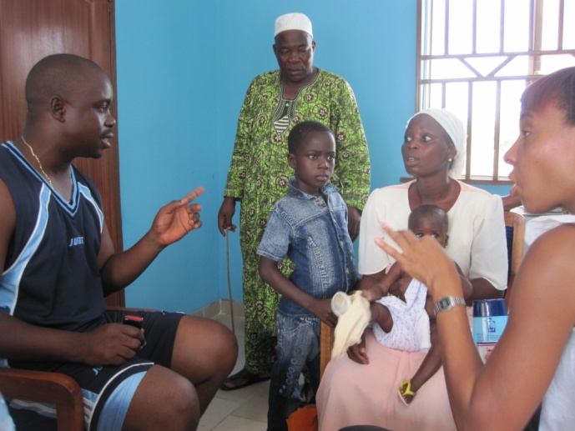
Figure : Mubeen bridging the communication gap (one-time volunteering)

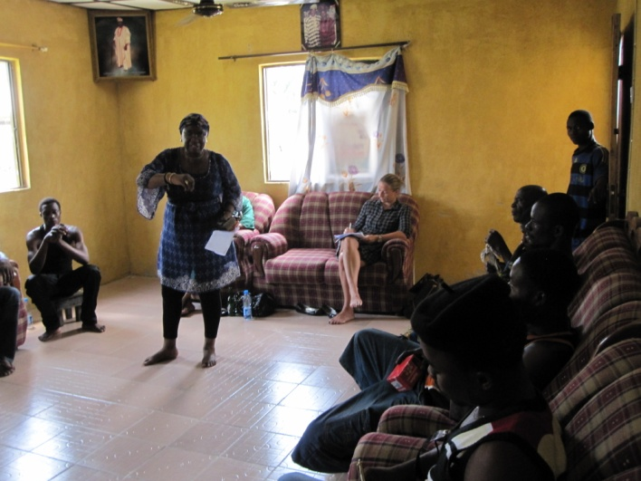
Figure : IAC Director (Mrs Orenuga) giving empowerment talk
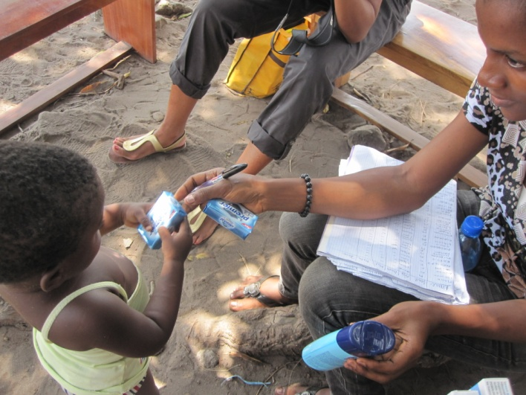
Figure : Senami (Part-time Volunteer) on a Medical Outreach to Taffi

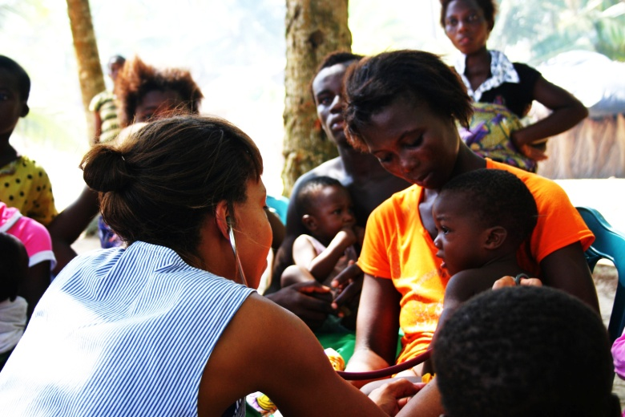
Figure : Dr. Olamide Dosekun (MBBS MRCP DipGUM DFSRH) attending to the sick
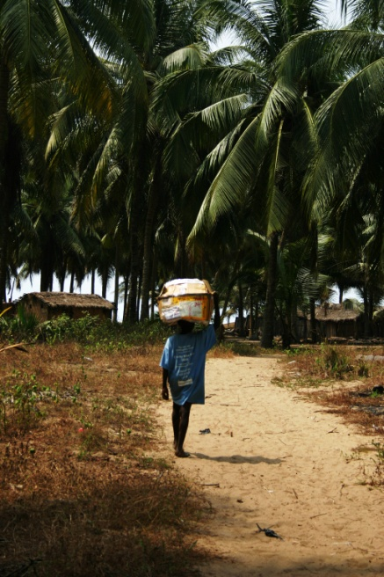
Figure : Little Nurideen helping to carry resources

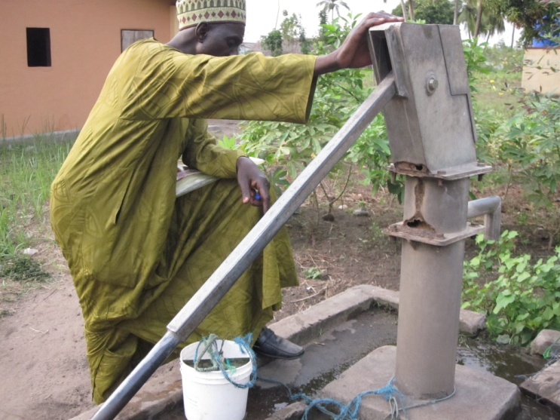
Figure : Mal Suleiman (TCF Water Technician) Inspecting a well
with its disused hand pump at Igbo Oja Nla

